# Press Release for Immediate Release

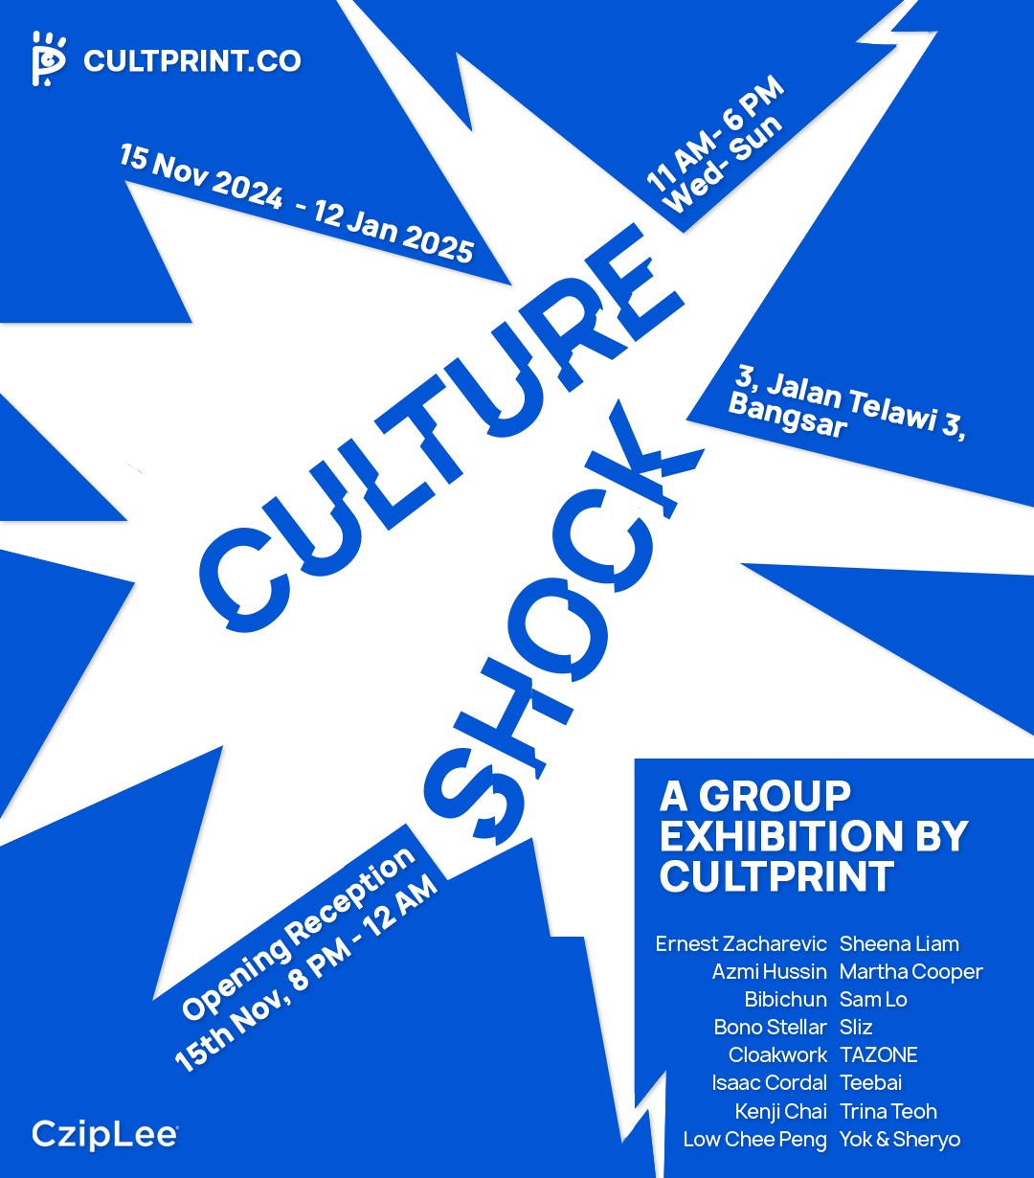

# “Culture Shock”

cultprint.co



hello@cultprint.co

An exhibition by **Cultprint**

15th November 2024 - 12th January 2025

3, Jalan Telawi, Bangsar,

59100, Kuala Lumpur, Wilayah Persekutuan

## Opening Reception- 8pm, 15th November

Kuala Lumpur, Malaysia – Cultprint is thrilled to announce ***“Culture Shock***,” an exciting group exhibition running from **November 15, 2024**, to **January 12, 2025** at the former Cziplee store in Jalan Telawi, Bangsar. Curated by Lithuanian artist **Ernest Zacharevic**, the exhibition will showcase an eclectic collection of works by prominent and emerging artists from around the world.

**“Culture Shock”** captures the interplay between Penang’s expressive creativity and Kuala Lumpur’s urban spirit. The exhibition brings together a diverse lineup of artists whose works span original pieces, prints, and installations. Featured artists include **Ernest Zacharevic, Sheena Liam, Azmi Hussin, Bibichun, Bono Stellar, Cloakwork, Isaac Cordal, Kenji Chai, Low Chee Peng, Martha Cooper, Sam Lo, Sliz, TAZONE, Teebai, Trina Teoh, and Yok & Sheryo.**

The exhibition unfolds across two levels, each offering a distinct experience. The ground floor comes alive with dynamic, playful collaborations that embody Cultprint’s energetic ethos, infusing humor and spontaneity. Meanwhile, the upper floor shifts to a more introspective and conceptual realm, offering visitors a chance to engage with thought-provoking and subtle narratives that explore deeper artistic intentions.

This carefully designed layout reflects Cultprint’s multifaceted identity, emphasizing its commitment to bridging different styles and interpretations within the contemporary art landscape. By juxtaposing these contrasting approaches, ***“Culture Shock”*** invites visitors to experience art in unexpected, immersive ways.

## Artistic Highlights

Amongst the many captivating pieces, ***“Culture Shock”*** features installations by **Bono Stellar** and **Cloakwork**; both Kuala Lumpur based artists with contrasting practices. **Cloakwork** brings his iconic graffiti tag indoors, juxtaposing his canvas pieces and Bono Stellar building on her iconic multidimensional visuals on mirrors.

Sculptures like **TAZONE’s** ***“Writers’ Bench”***; a throne made from used spray cans, and Spanish artist **Isaac Cordal’s *“Follow the Leaders”***; a cement block with his signature figurines takes center stage in the upper level.

Expect unusual collaborations from **Sheena Liam** and **Teebai** with their embroidered undergarments. **Azmi Hussin** and **Kenji Chai’s** latest print ***“The Great Escape”,*** legendary photographer **Martha Cooper** and **Ernest Zacharevic** with their collaborative print ***“Lil Crazy Legs”***, highlighting the playful spirit fostered by Cultprint.

With over 50 unique artworks from 16 different artists, the exhibition will showcase artist’s editions of all kinds such as sculptures, lithographs, photographic works, unique and hand finished variants.

cultprint.co



hello@cultprint.co

**Exhibition Details:**

Dates: November 15, 2024 – January 12, 2025

Venue: 3, Jalan Telawi 3, Bangsar

Opening Hours: Wednesday – Sunday, 11:00 AM – 6:00 PM (Closed on Mondays and Tuesdays)

For more information, please contact us at: **hello@cultprint.co** or +6011-1608 9935

## About Cultprint

Cultprint was founded by artists **Ernest Zacharevic** and **Sheena Liam**, Cultprint was first established as a printing studio in George Town, Penang and has since blossomed into a dynamic hub for artists, collectors and the community. With a focus on artistic expression and guarding the artist’s vision, Cultprint gradually expanded into a gallery space hosting an artist residency program. Our past exhibitions provided artists the environment to pursue ideas on a grander scale, forgoing any preconceived limitations about mediums or themes. Through residencies at Cultprint, artists nurtured their pursuits by collaborating, elevating their practice through efforts of skill-sharing and reciprocal teaching.